Job – 5

Aim: To document the process of downloading and installing various software applications: Zoom, Webex, Microsoft Teams, and the Dev-C++ IDE.

Theory
Software installation is the process of setting up a program on a computer so it can be executed. The standard procedure involves downloading an installer package from the software's official website, which ensures the application is secure and up-to-date.
Installers can be categorized into two main types based on the files included:
- Full (Offline) Installers: These are large, self-contained packages that include all the necessary files to complete the installation without an active internet connection. In this lab, both Zoom and Dev-C++ used this type of installer.
- Web (Online) Installers: These are small initial files that require an active internet connection during setup to download the required application files from the developer's servers. Webex and Microsoft Teams used this method.
Upon execution, the installer or setup wizard guides the user through configuration, which often includes accepting a license agreement, choosing an installation directory, and selecting optional components.

Steps for Installation
The following sections detail the installation process for Zoom, Webex, and Microsoft Teams.
I. Downloading and Installing Zoom
- Navigate to the Website: Open a web browser and go to the official Zoom download page. Select the appropriate version for your system.
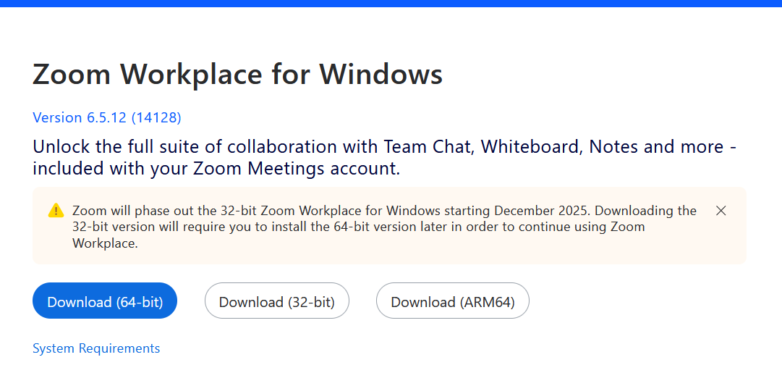
Figure 1 Selecting the installer
- Download the Installer: The installer file (ZoomInstallerFull.exe) will begin downloading. Monitor the progress in your browser's download manager.
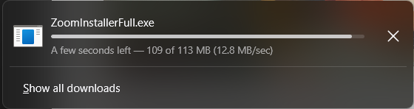
Figure 2 Downloading the installer
- Run the Installer: Once the download is complete, locate the file and double-click it. The Zoom Workplace Installer will launch and begin to initialize.
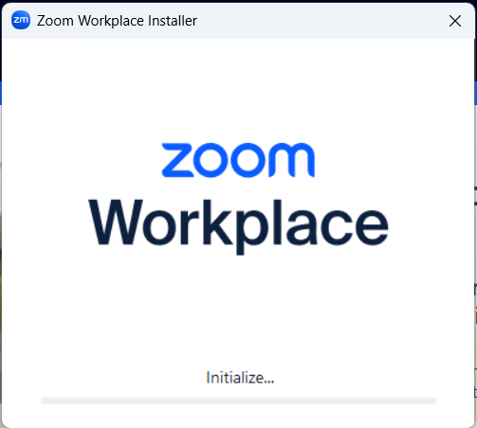
Figure 3 Launching the installer
- Complete Installation: After the process finishes, a confirmation window will appear stating that the installation was successful. Click "Done".
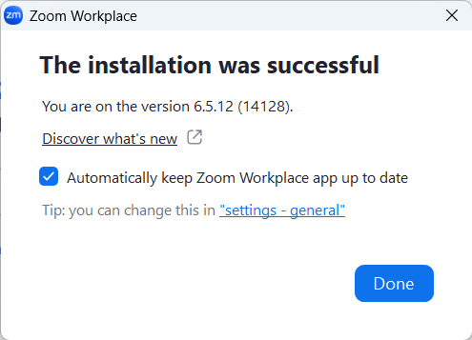
Figure 4 Finishing the installation
- Launch the Application: The Zoom Workplace application will open automatically, displaying the sign-in screen. The software is now successfully installed.
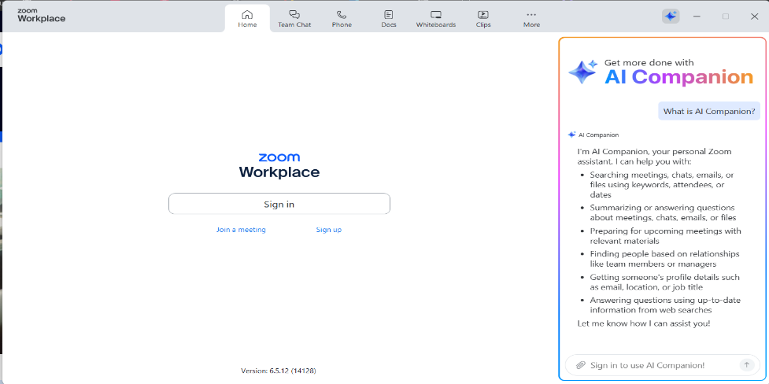
Figure 5 Application Interface

II. Downloading and Installing Webex
- Navigate to the Website: Go to the official Webex download page and click the "For Windows (64 bit)" button to start the download.
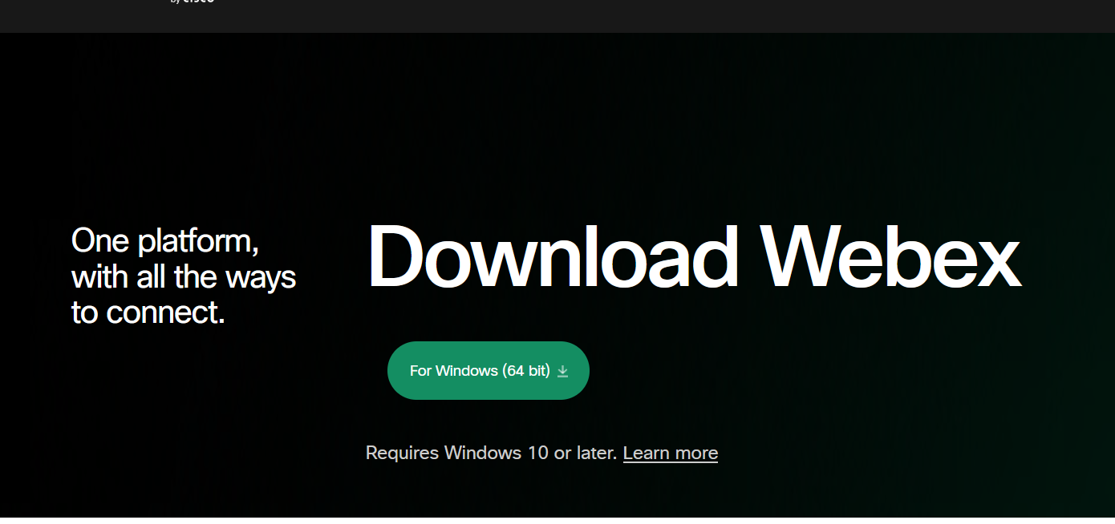
Figure 6 Downloading Webex
- Locate the Installer: Once the download is finished, find the Webex.exe file in your downloads folder.
Figure 7 Locating the installer
- Run the Installer: Double-click the Webex.exe file. The Webex installer will launch and begin installing the application on your computer.
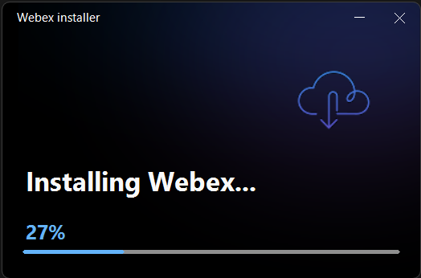
Figure 8 Installing Webex
- Agree to Terms: During the installation, a window with the software's terms of service will appear. Click "Agree" to proceed.
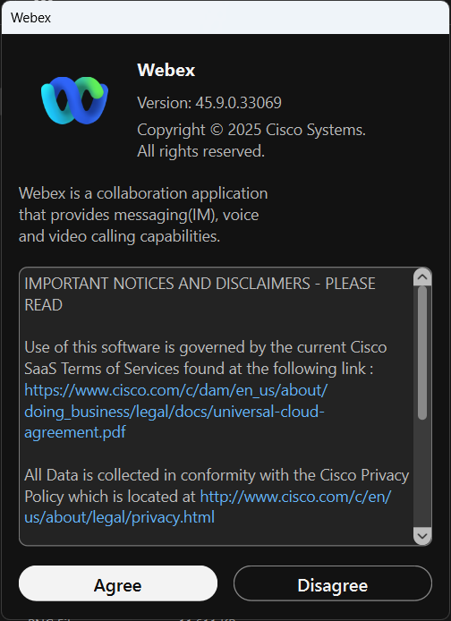
Figure 9 Webex license agreement window

- Complete Installation: Once the installer finishes, the Webex application will open. The software is now installed and ready for use.
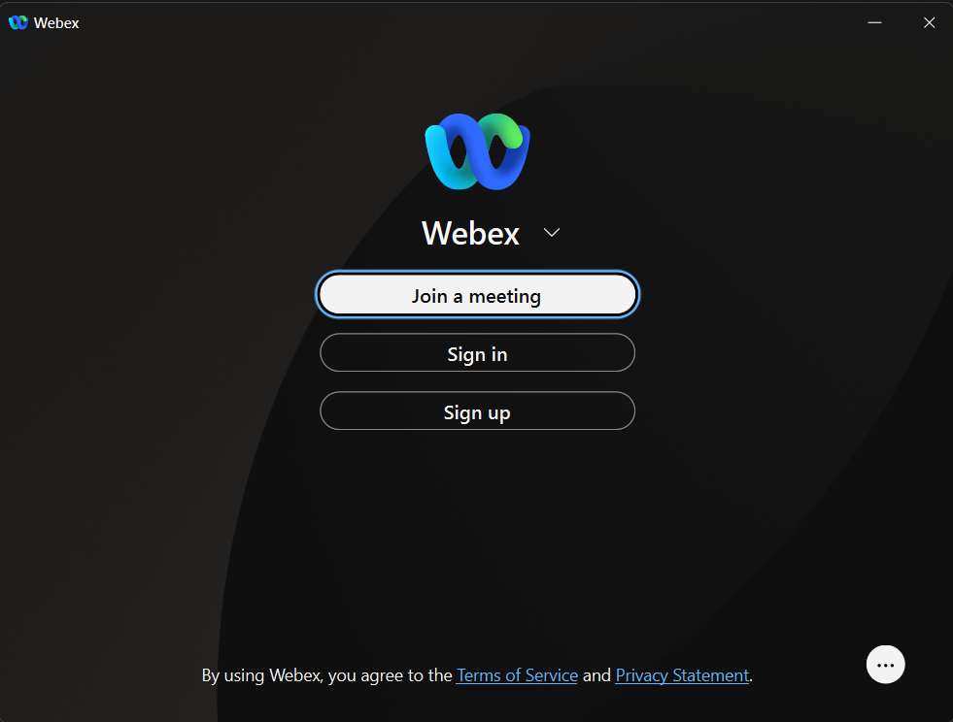
Figure 10 Webex Interface

III. Downloading and Installing Microsoft Teams
- Navigate to the Website: Go to the official Microsoft Teams download page and click the "Download Microsoft Teams for Windows" button.
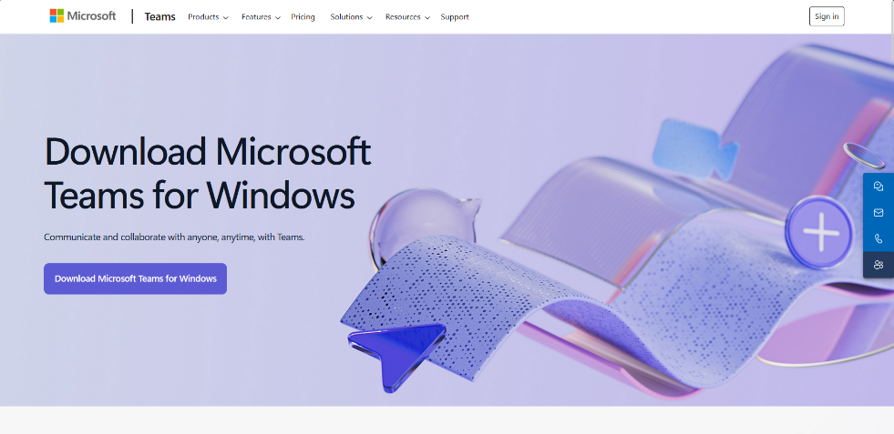
Figure 11 The official Microsoft Teams download webpage.
- Locate the Installer: After the download is complete, find the installer file, named MSTeamsSetup.exe, in your downloads folder.
Figure 12 The MSTeamsSetup.exe installer file
- Run the Installer: Double-click the MSTeamsSetup.exe file to launch it. A window will appear, and the installer will begin downloading the application files.
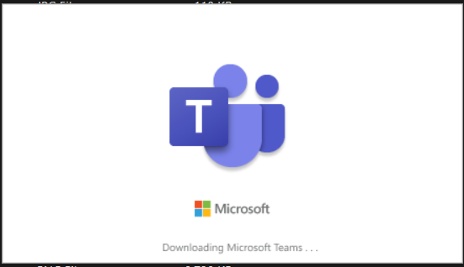
Figure 13 The splash screen shown during the Teams installation.
- Complete Installation: Once the download and installation are finished, the Microsoft Teams application will open. The software is now installed and ready to be used.
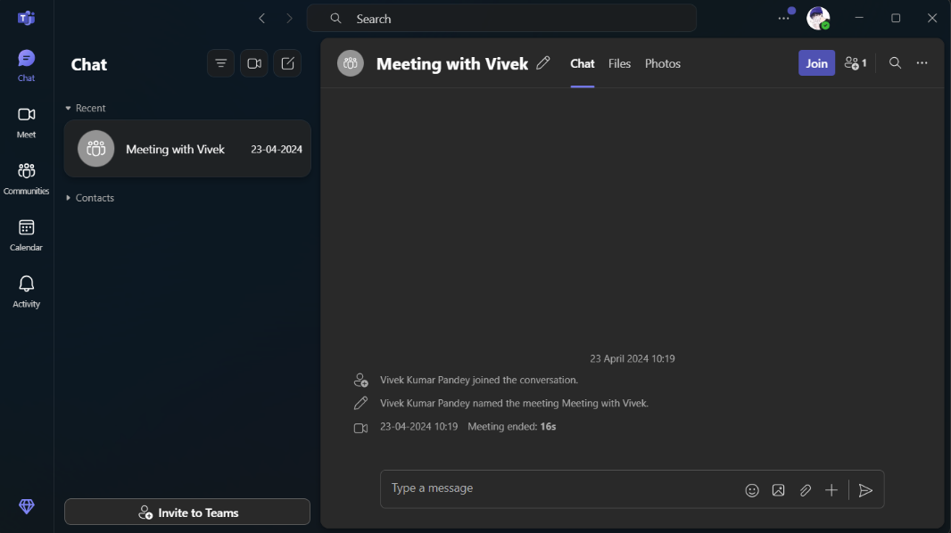
Figure 14 The Microsoft Teams application after successful installation.

IV. Downloading and Installing Dev-C++
- Navigate to the Website: Go to the Dev-C++ download page on SourceForge and click the green "Download" button to get the installer.
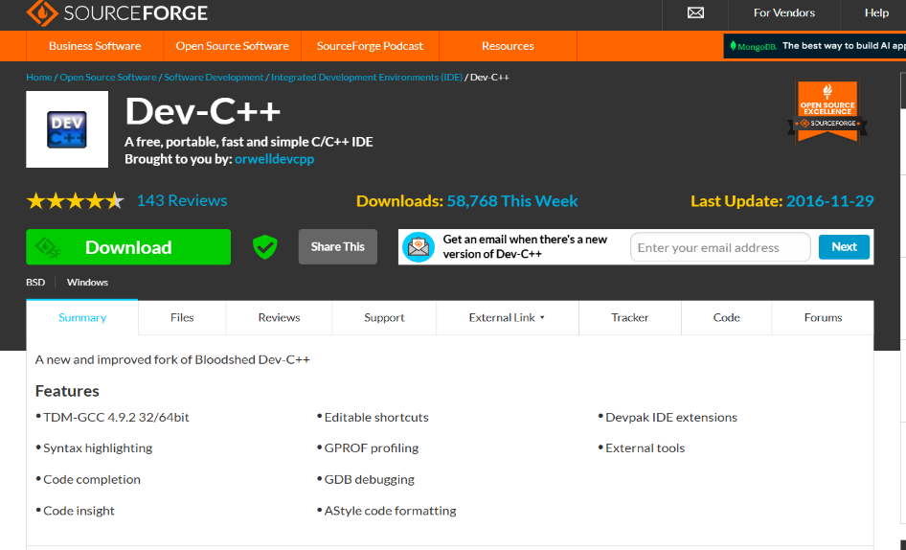
Figure 15 The official Dev-C++ download page.
- Locate the Installer: After the download is complete, find the setup file (e.g., Dev-Cpp 5.11 TDM-GCC 4.9.2 Setup) in your downloads folder.
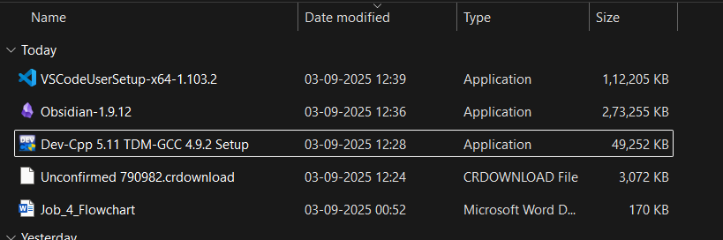
Figure 16 The Dev-C++ setup file in the downloads folder
- Run the Installer and Select Language: Double-click the setup file. A window will pop up asking you to select a language for the installer. Choose your preferred language and click "OK".
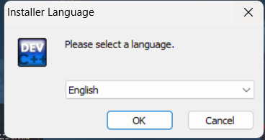
Figure 17 Selecting the language for the installer
- Agree to License: Read the GNU General Public License and click "I Agree" to continue with the installation.
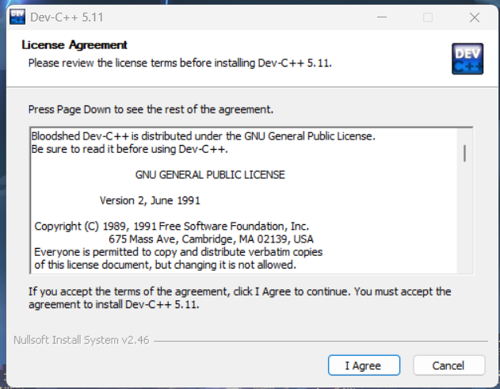
Figure 18 Agreeing to the GNU General Public License
- Choose Components: Select the components you wish to install. For a standard setup, leave the type of install as "Full" and click "Next".
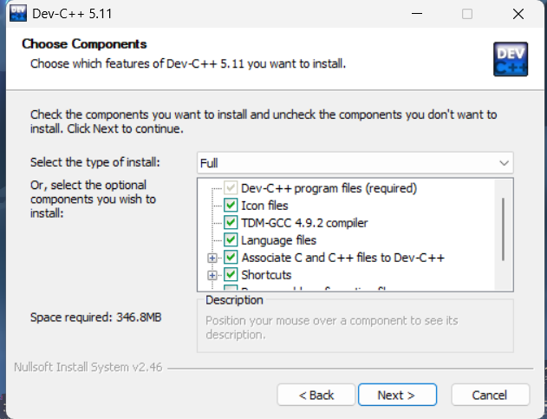
Figure 19 Choosing the installation components
- Choose Install Location: Select the destination folder for the installation. The default location is usually fine. Click "Install" to begin copying the files.
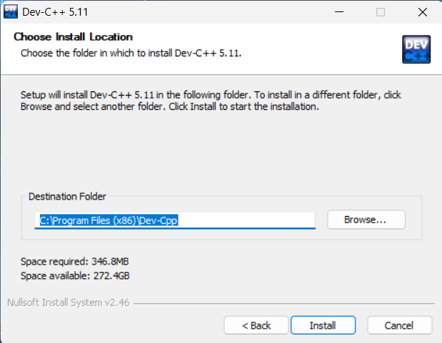
Figure 20 Confirming the installation directory
- Wait for Installation: The installer will now extract and install all the necessary files onto your computer.
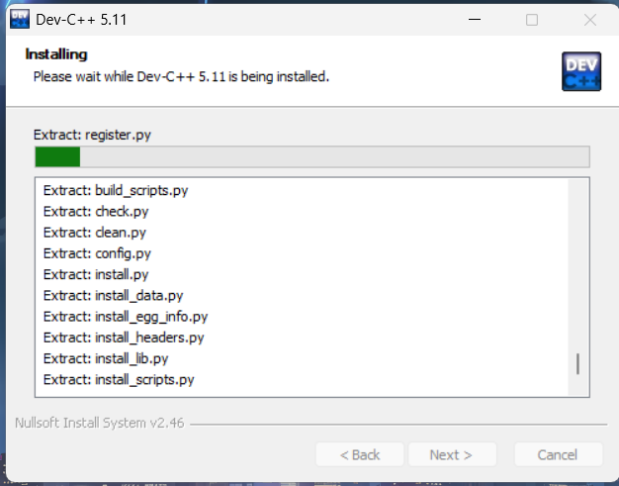
Figure 21 The installation process for Dev-C++
- Finish Setup: Once the installation is complete, click "Finish". Ensure the "Run Dev-C++ 5.11" box is checked to open the application right away.
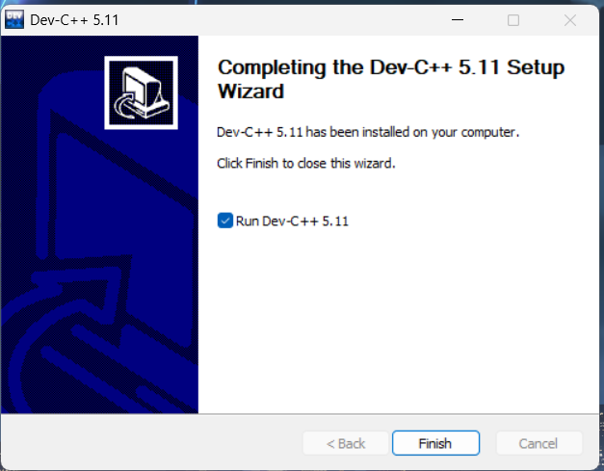
Figure 22 Completing the installation wizard
- First-Time Configuration: When Dev-C++ runs for the first time, it will ask you to select a language for the application interface. Choose your language and click "Next".
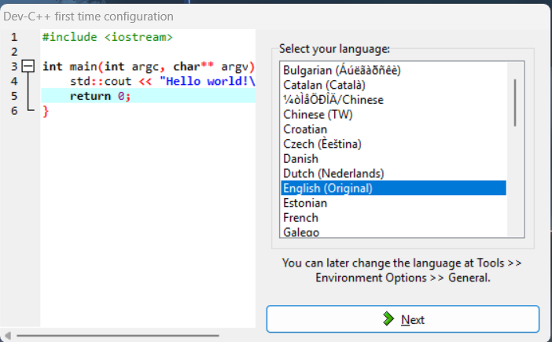
Figure 23 Selecting the application language on first startup

10. Configuration Complete: A final message will confirm that the configuration was successful. Click "OK". Dev-C++ is now installed and ready to use.
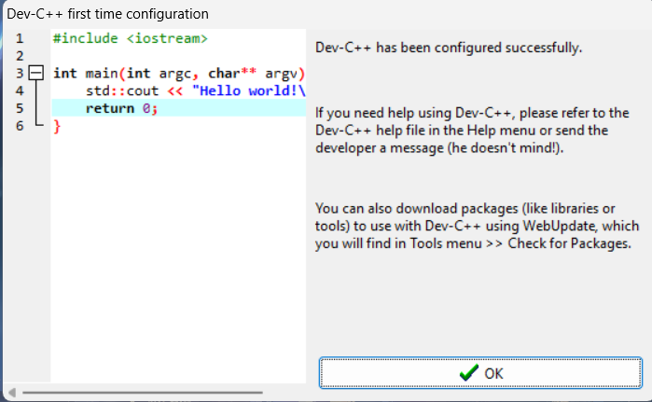
Figure 24 The confirmation of a successful setup

Conclusion:
Successfully downloaded and installed four essential software applications, confirming their readiness for use. The process involved different types of installers, including full offline packages for Zoom and Dev-C++, and web installers for Webex and Microsoft Teams.

